Assignment 2 - COMP 249

Due Date: March 4th

Question: Part 2

Written by: Augusto Mota Pinheiro (40208080)

Michaël Gugliandolo (40213419)

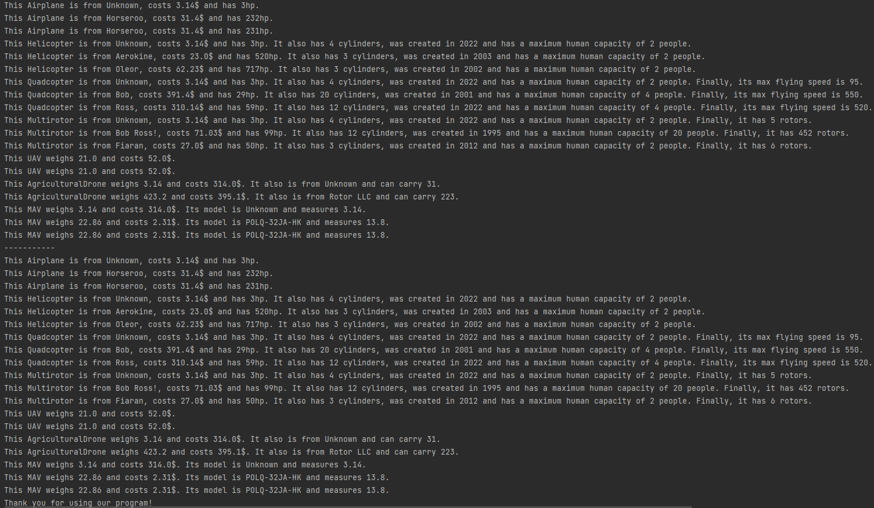

The toString methods from the flying objects in the first array print out the correct information.

Also, each flying object class has its own deepCopy method, overridden from the abstract superclass. This allows us to copy the right type of object by calling this method, even without knowing the type of flying object. So, as shown in the output, the information of the copied array is exactly the same as the original array, indicating that our method copyFlyingObjects performed as expected.